**SHINE UTENSILS**

*Developer Guide*

|  |  |  |
| --- | --- | --- |
| **Supervisor.** | **Miss Aatika** | |
| **Batch.** | **2110c1** | |
| **Group.** |  | |
| **Serial No.** | **Enrollment Number** | **Student Name** |
| 1. | 1340176 | MAHNOOR |
| 2. | 1341258 | NEHA |
| 3. | 1341255 | HASHIR AHMED |

**1.HOME(**Index.html**)**

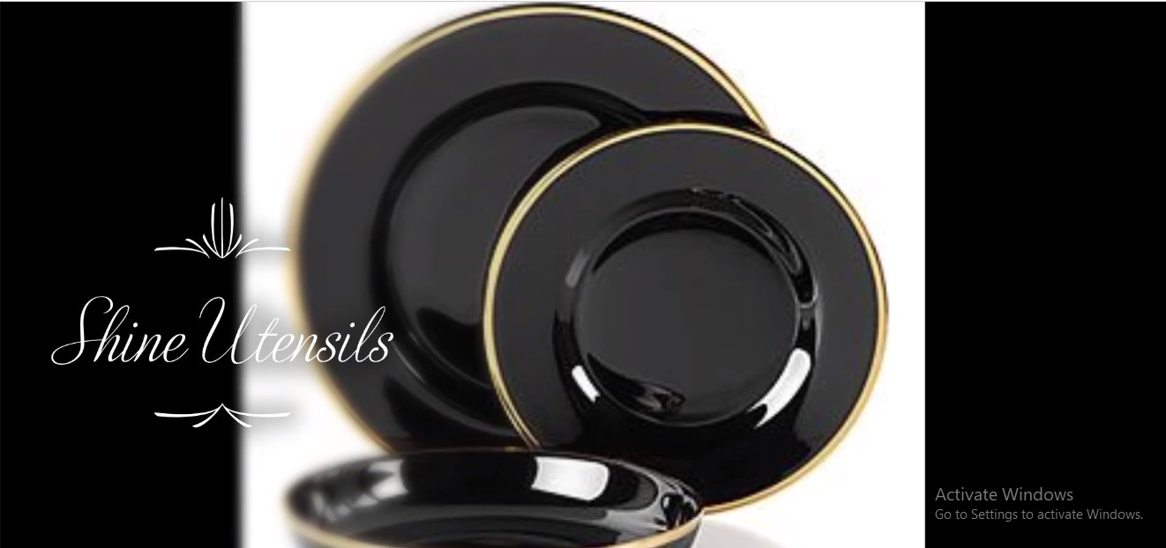

***Figure 1: Home page to shine utensils***

* Our Slogan has given to the peoples toward our website. “**Our utensils a day keeps bad food away**”.
* Home page contain utensils video

**2.NAVBAR(**Index.html**)**



***Figure 2: Navbar***

We have given eleven essentials. By clicking any of the essential’s and redirect to the linked page. (index.html)

**3.FOOTER(**Index.html**)**

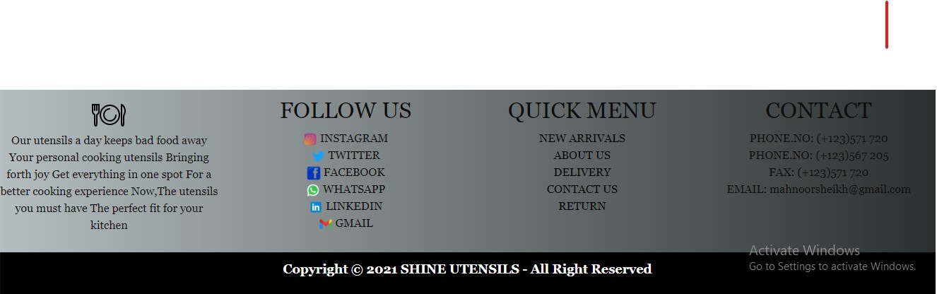

***Figure 3: FOOTER***

***4.MIDDLE PAGE OF HOME (index.html)***

***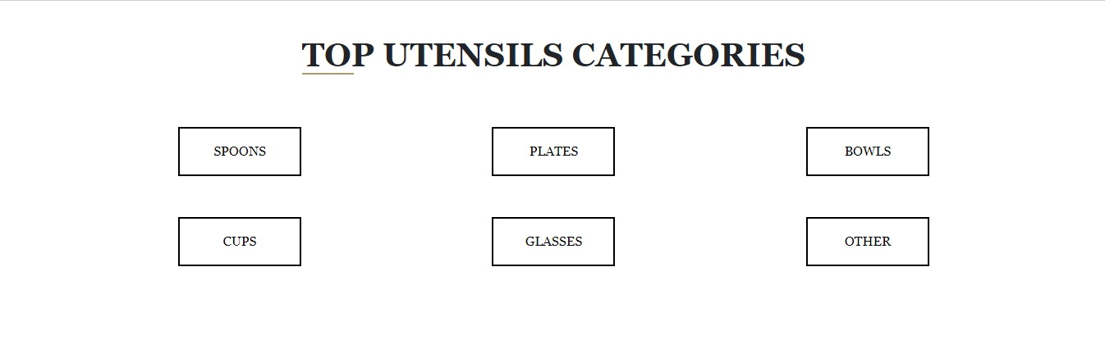*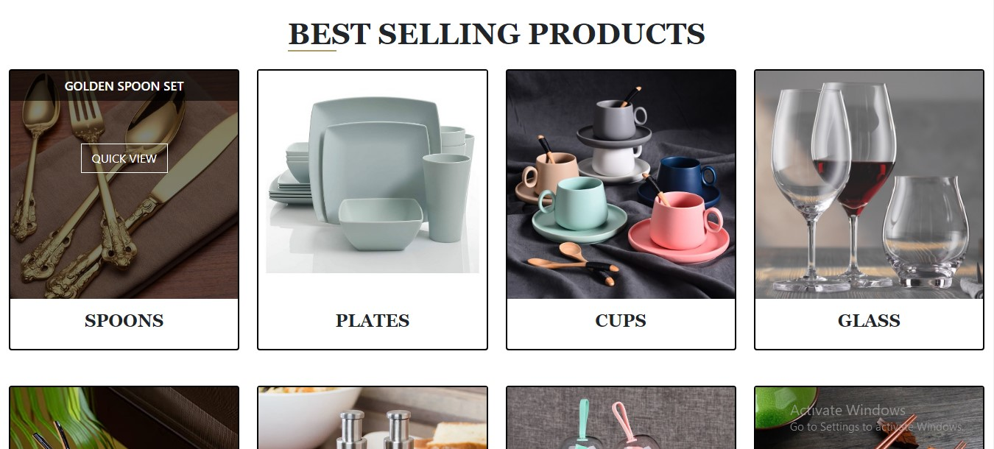**

***Figure 4: MIDDLE PAGE OF HOME***

* Home page contain top utensils categories with button of all categories on click of each button page redirect to its main page
* Also include some best-selling product of utensils with product detail quick view

**5.ABOUT (ABOUT.**HTML)

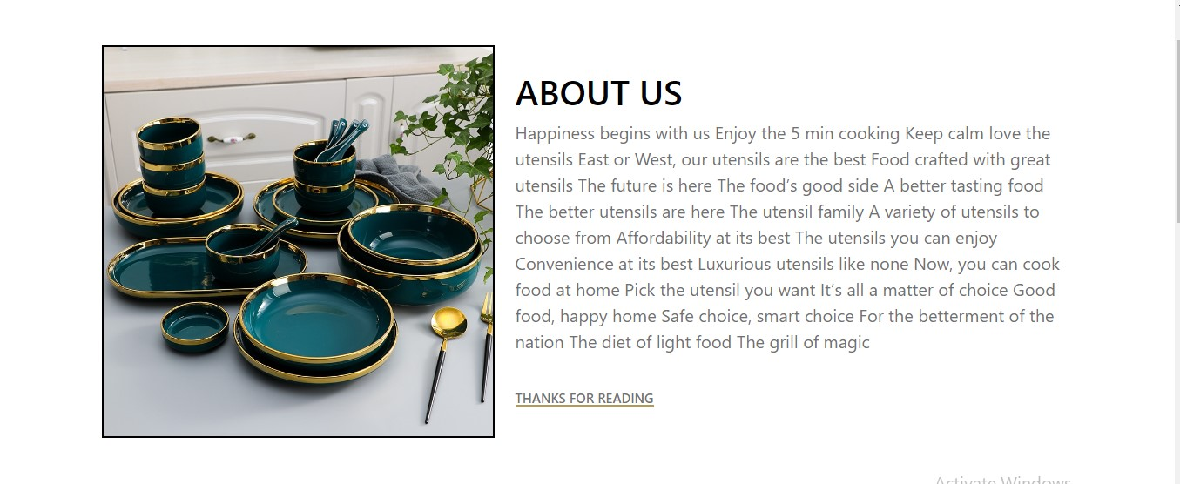

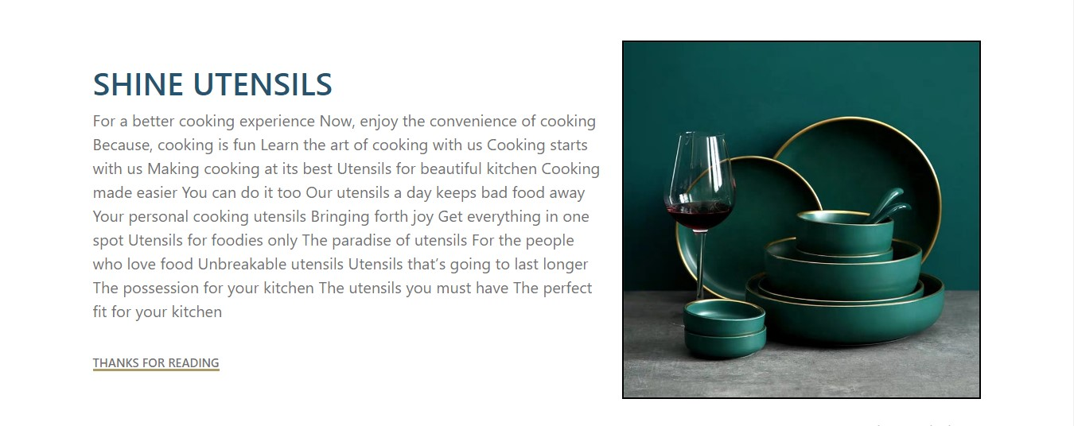

***Figure 5: ABOUT***

*  The utensils you must have the perfect fit for your kitchen*

* Cooking starts with us*

*Making cooking at its best*

*Utensils for beautiful kitchen*

**6.CONTACT US (**CONTACT.HTML)



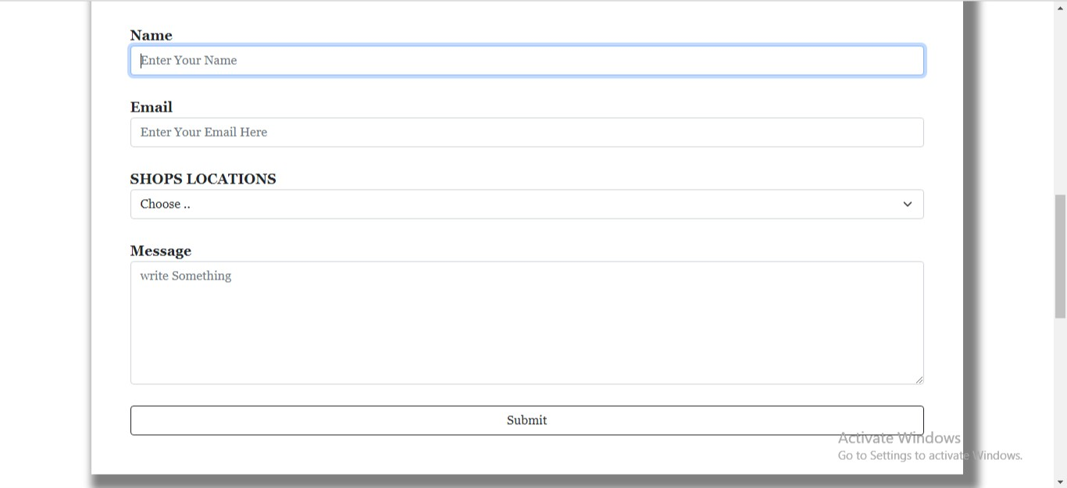

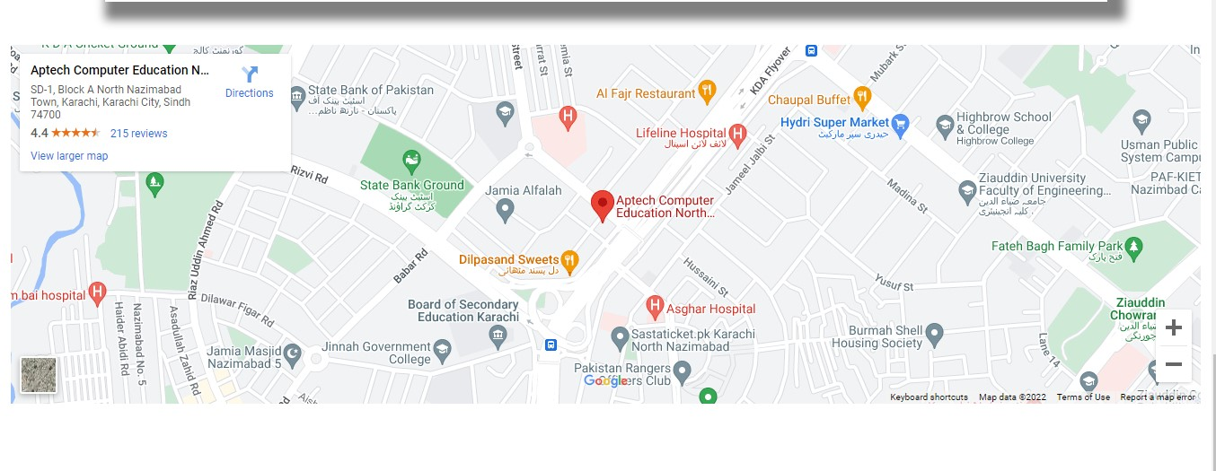

***Figure 6: CONTACT US***

**7.FEEDBACK (**feedback.html)

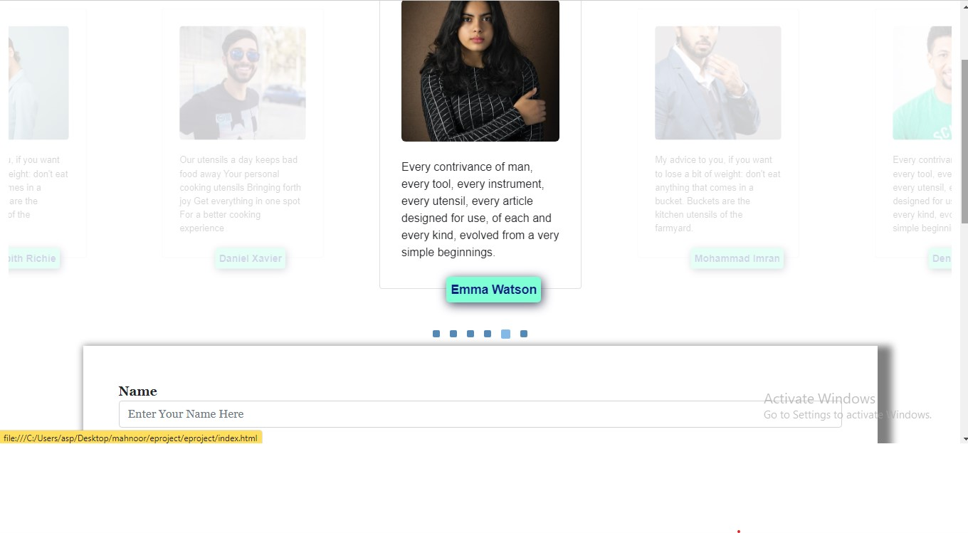

***Figure 7: FEEDBACK PAGE***

**8.CATEGORIES** PAGE (spoons.html)

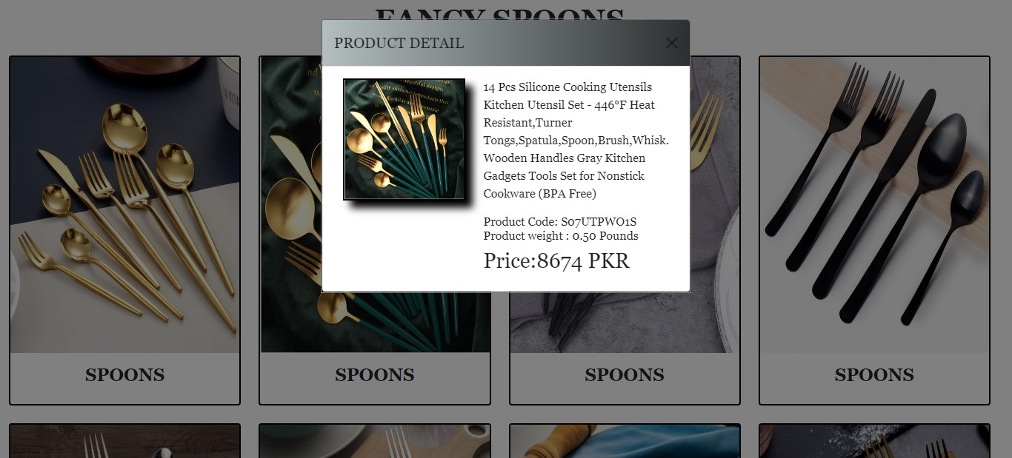

***Figure 8:*** CATEGORIES PAGE

*  ALL CATEGORIES PAGES ARE SAME AS SPOON*

* CATEGORIES PAGE INCLUDES*

* + - * *PLATES*
      * *CUPS*
      * *BOWLS*
      * *SPOONS*
        + *GLASS*
        + *OTHERS*

**9.COMPARE** PRODUCTS (compare.html)

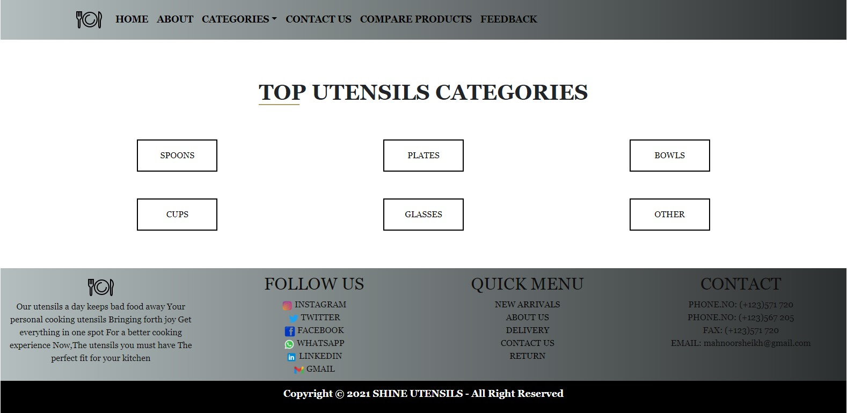

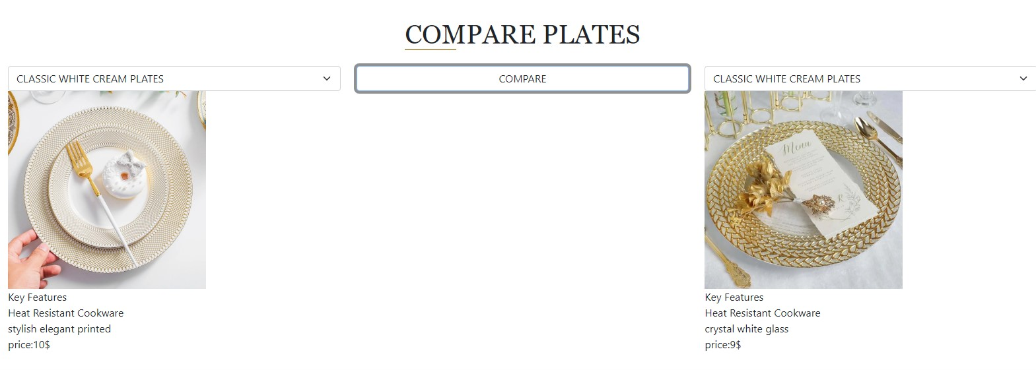

***Figure 9:*** COMPARE PRODUCTS

* Compare page contain all categories comparison product individual page
* In main comparison product page, we add button if anyone want spoon comparison so click on the spoon button which redirect to its main page and for all the categories you do the same process